Inside-Out Development:

Church-Based Efforts to Develop Kibera Slum

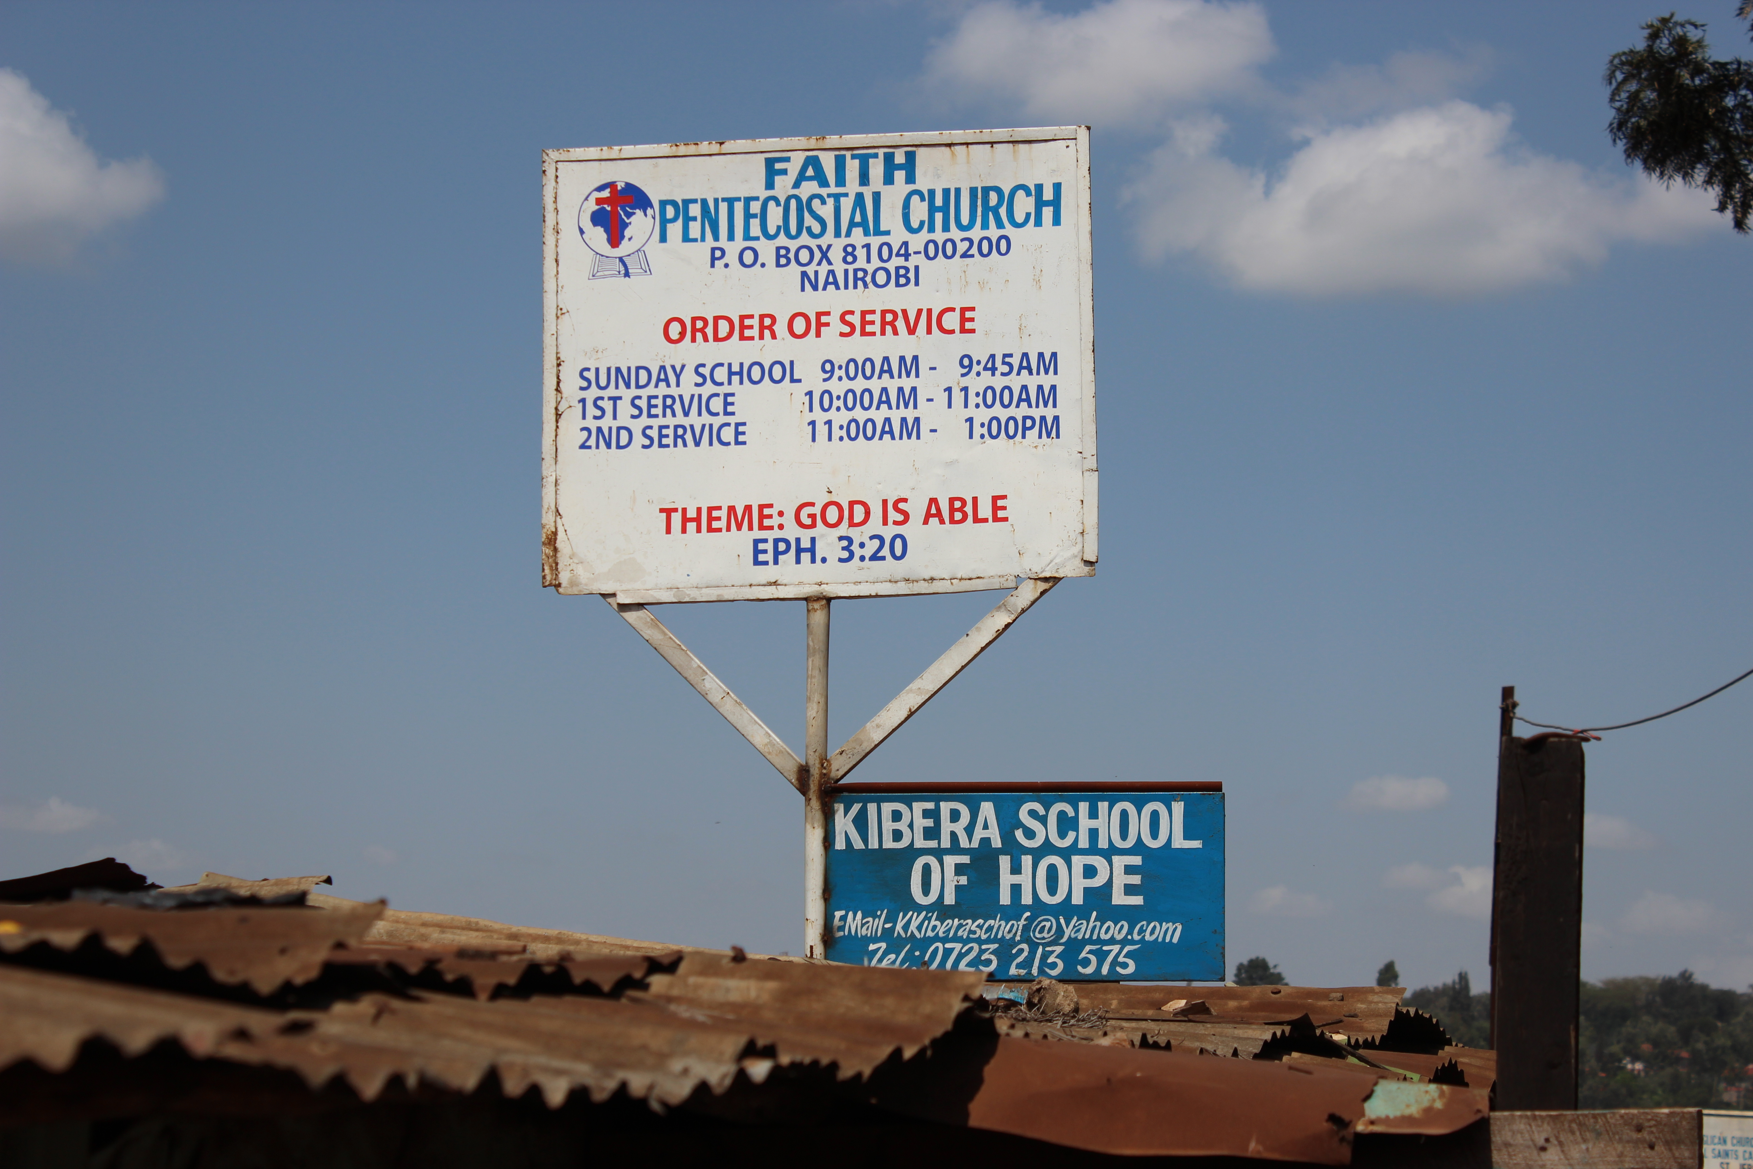

Adam Cramer
Final Master’s Project
Master of Arts in Transformational Urban Leadership
Azusa Pacific University
July 2014

Table of Contents

List of Tables and Figures………………………………………………………………………..i
I. Abstract…………………………………………………………………………………………1
II. Introduction…………………………………………………………………………………...2
III. Literature Review…………………………………………………………………………….4
Global Research on Slum Development……………………………………………………4
Donor-Driven vs. Community-Driven Development………………………………4
Donor-Driven Development……………………………………………………….5
Community-Driven Development………………………………………………….6
Development Strategies in Kibera Slum……………………………………………………7
A Case Study: Top-Down vs. Bottom-Up Development in Kibera………………....7
Government Attempts for Participatory Development……………………………..8
Church-Based Development in Kibera Slum……………………………………………….8
Literature Reflections………………………………………………………………………9
IV. Theological Reflections……………………………………………………………………..10
Arguments Against Church-Based Development………………………………………….10
Practical Arguments……………………………………………………………….10
Biblical Arguments………………………………………………………………..12
Arguments For Church-Based Development……………………………………………………...13
Practical Arguments……………………………………………………………….13
Biblical Arguments………………………………………………………………..13
V. Community Context………………………………………………………………………….16
Nairobi, Kenya……………………………………………………………………………16
Kibera Slum………………………………………………………………………………16
VI. Methods……………………………………………………………………………………...18
Research Biases…………………………………………………………………………....18
Research Questions……………………………………………………………………….18
Partner Organization……………………………………………………………………...18
My Father’s House Ministry………………………………………………………18
A Participatory Approach…………………………………………………………………19
Sample Selection…………………………………………………………………………..20
Data Collection…………………………………………………………………………....21
Ethical Considerations…………………………………………………………………….21
Outcomes…………………………………………………………………………………22
VII. Description of Research Findings………………………….……………………………..23
Key Demographics and Findings………………………………………………………….23
Emerging Themes………………………………………………………………………....26
Small and Young Churches………………………………………………………..26
Education…………………………………………………………………………27
Economic Development…………………………………………………………..27
Poor Churches…………………………………………………………………….27
(Lack of) Church Partnerships…………………………………………………….27
Negative Perspective……………………………………………………………....27
Summary………………………………………………………………………………….28
VIII. Research Analysis…………………………………………………………………………29
Implications of Research Findings………………………………………………………...29
Making Something Out of Nothing……………………………………………….29
Prioritizing Greatest Development Needs………………………………………....29
Inside-Out Development Works…………………………………………………..30
Variables Which Affect Church-Based Development……………………………………...30
Partnerships……………………………………………………………………….30
Lack of Resources………………………………………………………………....31
Handout Mentality………………………………………………………………...31
IX. Recommendations…………………………………………………………………………..33
Short-Term Action Steps………………………………………………………………….33
Awareness of the Resources and Capacity for Grassroots Development in Kibera..33
Awareness of Other Church-Based Development Initiatives……………………...33
Starting the Conversation…………………………………………………………33
Developing Partnerships…………………………………………………………..34
Long-Term Action Steps………………………………………………………………….34
A Network of Church Partnerships……………………………………………….34
X. Research Significance………………………………………………………………………..35
Contributions to the Field of Research……………………………………………………35
Contributions to the Host Organization and Community…………………………………35
Limitations of Research…………………………………………………………………...36
Additional Research Needed……………………………………………………………...36
XI. Conclusion…………………………………………………………………………………...37
Bibliography……………………………………………………………………………………..38
Appendix 1: Acknowledgements………………………………………………………………..40
Appendix 2: Interview Questions………………………………………………………………41
Appendix 3: Handout for Public Presentation of Research…………………………………..42
Appendix 4: GANTT Chart for Research Process…………………………………………….46
Appendix 5: Research Budget………………………………………………………………….47

List of Tables and Figures

Table 4.1: Charity vs. Development………………………………………………………………11
Table 7.1: Denominational Demographics of Surveyed Churches………………………………...23
Table 7.2: Basic Demographic Data of Participating Churches/Pastors…………………………..23
Table 7.3: Salaried vs. Non-Salaried Pastors……………………………………………………....24
Table 7.4: Interview Data: Needs/Challenges in Kibera………………………………………….24
Table 7.5: Interview Data: Resources/Assets in Kibera…………………………………………..24
Table 7.6: Community Partnerships for Surveyed Churches……………………………………...25
Table 7.7: Percentage of Development Work Among Surveyed Churches………………………..25
Table 7.8: Different Types of Development Work Among Surveyed Churches…………………..25
Table 7.9: Interview Data: Methods for Developing Kibera……………………………………...26

Figure 5.1: Map of Kenya………………………………………………………………………...16
Figure 5.2: Kibera Slum…………………………………………………………………………..16
Figure 6.1: Pastor Mike Aloo, Research Assistant………………………………………………...20
Figure 6.2: Map of Kibera’s 13 Villages…………………………………………………………..21
Figure 7.1: Children From A Church-Based Slum School………………………………………...27

I. ABSTRACT

The purpose of this study was to investigate the efforts of poor churches in Kibera slum towards developing the community. Kibera is the second largest slum in all of Africa, and its many challenges include immense poverty, disease, lack of education, and lack of jobs.

A significant amount of literature has been written on models for slum development. These models generally fall under two categories: 1) donor-driven development and 2) community-driven development. The former promotes a top-down approach to development, while the latter employs a bottom-up approach. Much has been written about donor-driven development in Kibera – and globally, but there is much less research on bottom-up development—and particularly on grassroots church-based development of Kibera. The intention of this study is to fill in that gap in the field of research, with implcations for the global discussion.

Utilizing a participatory action process, this study was done in collaboration with My Father’s House Ministry—a local ministry in Kibera that operates as a training center for pastors and church leaders in the slum.. The leadership at My Father’s House helped to formulate the research question and design the research process in a way that was empowering to the community.

For this study, 42 out of approx. 800 pastors of slum churches in Kibera were interviewed about the development efforts of their churches. Despite overwhelming barriers, the study reveals that the churches in Kibera are doing exceptional work to develop the slum. These churches are largely focusing on economic development, education, and healthcare.

The results of this research were reported back to the host organization and the participants in the study, with proposed recommendations for further action. The conclusion of this study is that the churches in Kibera are doing good work in the community, but they could reach an even greater capacity for transformational development of the slum by partnering together in their development efforts.

II. INTRODUCTION

I’ve lived in Kibera for 35 years, and I can’t see anything good here. I guess the worshipers in church are the only good thing.

PASTOR SILVANO ODINDO
HOPE GOSPEL CHURCH, KIBERA

If someone were asked to describe “hell on earth,” they might begin describing one of the growing number of 21st-century urban slums. Today’s slums are places filled with extreme poverty and disease. Violence and abuse is often the norm in such communities, and the phrase “human rights” carries such little meaning in a place that is at times beyond human recognition. Slum dwellers are a marginalized people, often unrecognized by the same cities that rely heavily on their labor force. Slums are the land of social oppression—with very little opportunity for upward mobility.

The above statements are all true, but they do not paint the entire picture with complete accuracy and integrity. The world’s urban slums have been described solely in a negative way for far too long.

Today’s urban slums are also communities teeming with life and energy. Despite their hardships, many people living in the slums are not asking anyone to feel sorry for them. These people are hardworking and proud. They often migrate to the mega-cities seeking a better life, much in the same way immigrants have flocked to America over the past few centuries. There are skilled craftsman in the slums—brilliant, innovative people. Slum communities are vibrant and colorful. They are filled with beautiful people who join together in community and share one another’s burdens. The depth of the shared bond in these communities—through a shared struggle—cannot be overemphasized. The slums are also often places of deep spirituality. The poor rely on their faith to carry them through life’s constant challenges. In many communities, this is the only way they know how to survive and continue pressing on.

I speak about today’s urban slums not as a theoretical proposition or something I read about in a book one time. No, over the past decade I have seen these slums with my own eyes. From Beijing to Calcutta, I have walked in today’s sprawling urban slums. I have been to the townships of South Africa—the leftover residue from the Apartheid government’s history of segregation and domination. I have seen Soweto in Johannesburg, which famously raised both Nelson Mandela and Archbishop Desmond Tutu to be fighters for justice and peace. I have seen these places with my own eyes.

For the past 18 months, my wife and I have been living in one of these slums—Kibera slum, in Nairobi, considered the 2nd largest slum in all of Africa. We have lived here among the people. Our first child was born here, in Kibera. We have made this our second home.

So when I speak about today’s slums, I speak as both an outsider and an insider. My privileged upbringing in America’s Midwest will always make me an outsider in a place like Kibera. My white skin will forever cement my position as a mzungu—a foreigner of European descent. I will always stick out like a sore thumb.

But I have seen that it is possible to be grafted in with a certain measure of “insider status.” As my family has attempted to live incarnationally in this slum, we have seen that over time we blend in—white skin and all. People have slowly accepted us as part of this community, and we no longer stand on the outside looking in.

A Kenyan friend of mine recently commended my wife and me for our adaptability. “Some people are down to earth,” he said, “but you guys are down to Kibera.” This was humbling, but perhaps the highest honor we could receive from a local person in the slum. He was essentially saying, “You have become one of us.”

This research project will include a lot of theory about urban slum development, much of which will be covered in the following literature review. However, I wanted to start with that personal note to emphasize that this project is not just about theoretical propositions. My wife and I did not move to Kibera and start our family here so that we could gain a theoretical perspective. For me, slum development is about life change. I want to see communities transformed, and I want to see lives changed; that is the heartbeat behind this project.

III. LITERATURE REVIEW

This literature review examines the existing research relevant to the topic of church-based slum development. These texts helped lay the groundwork for the student researcher’s understanding of slum development issues. This groundwork ultimately led to the development of this study.

Very little local research has been done specifically on church-based slum development in Kibera, so accordingly the literature on this narrow topic is limited. In order to get a broad perspective on this topic, this review will start with a wider focus, before narrowing in on the specific topic at hand. This review will focus on three areas of particular interest to this study: 1) Global Research on Slum Development; 2) Development Strategies in Kibera Slum; and 3) Church-Based Development in Kibera Slum.

GLOBAL RESEARCH ON SLUM DEVELOPMENT
The United Nations has been central to the ongoing global conversation on urban poverty and development. The United Nations Millennium Summit in 2000 took direct aim at significantly reducing urban poverty. UN Millennium Development Goal 7, Target 11, proposes to have “achieved by 2020 a significant improvement in the lives of at least 100 million slum dwellers” (Garau et al., 2005, p. xxi). In making this target, the UN has thrust urban poverty—which is often overlooked in conversations on global poverty—to the forefront of the discussion.

Simply acknowledging urban slums as a problem is a major step forward from the historical position, which promoted indifference, inaction, and in many cases injustice towards the suffering millions in the world’s slums. Garau et al. (2005) writes:

Often attention to the slum dwellers of the world has been largely a matter of inaction, inappropriate action, or insufficient action. The most common government policies over the past 40 years have been to ignore slums or, when they are on valuable land, bulldoze them. (p. 10).

By acknowledging that urban slums are a major problem, organizations like the UN are also now proposing that there must be solutions to the problem. Slum development is a widely debated topic with varying global perspectives on the best practices for meeting this UN Millennium Goal.

Donor-Driven vs. Community-Driven Development
There are two major voices in the development world today that are shaping two very different perspectives on development theory. Leading economists Jeffrey Sachs and William Easterly have both made major efforts in framing the issues and proposing the way forward for the ongoing development of poor nations and communities. They are both striving toward the same goal, but their perspectives and methods could not be further apart.

Donor-Driven Development
Jeffrey Sachs, who directed the UN Millennium Project from 2002-2006, proposes a top-down, donor-driven approach to development. He argues that the past 250 years of global economic growth has positioned us to put an end to widespread poverty. In perhaps his most significant work of literature, The End of Poverty, Sachs (2005) writes, “We can realistically envision a world without extreme poverty by the year 2025 because technological progress enables us to meet basic human needs on a global scale and to achieve a margin above basic needs unprecedented in history” (p. 347).

Because of our unique position in history, Sachs sees this generation as having the opportunity to promote global advancement like never before in four key areas:
- Fostering democratic political systems that promote human well-being
- Fostering a global economic system that spreads the benefits of science, technology, and the division of labor across the planet
- Fostering world peace through international cooperation
- Promoting science and technology in order to continue improving the human condition (Sachs, 2005, pp. 351-52).

A key component to Sachs’ argument is a fundamental belief in the benefits of globalization. Sachs opposes the antiglobalization movement for a number of reasons, which he outlines in The End of Poverty. He writes, “An anticorporate animus lies at the core of the movement, a belief that multinational corporations such as Microsoft, Coke, McDonald’s, Pfizer, and Royal Dutch Shell, to name just a few, are the main villains in causing extreme poverty and environmental degradation” (p. 355). Sachs sees these as “superficial targets.”

Sachs understands that many large corporations have behaved badly—a major point of emphasis in the antiglobalization movement—but he sees the argument against globalization as being shortsighted. For Sachs, these arguments distort the overwhelming potential for capacity building in a global capitalistic economy. He writes, “…the antiglobalization movement should mobilize its vast commitment and moral force into a proglobalization movement on behalf of a globalization that addresses the needs of the poorest of the poor, the global environment, and the spread of democracy” (p. 358). Sachs coins the phrase “Enlightened Globalization” to describe this 21st-century phenomenon.

In his book Walking with the Poor, Bryant Myers (2011) defines Sachs’ position well: “At the beginning of the twenty-first century the four horsemen of modernity—capitalism, globalization, science, and technology—still offer to save the poor. The claim is made that things are getting better, at least a little” (p. 171).

Ultimately, Sachs’ approach to develop poor countries is focused on foreign donors from the world’s wealthiest countries. Kelley (2008) writes, “The core of Sachs’ prognosis is targeted investments backed by aid from donor countries….Because the poor are unable to overcome the poverty trap, donor countries must take steps to establish or reestablish a healthy economy” (p. 153). Sachs makes this bold claim: “For less than 1 percent of annual income of the high-income countries—the U.S., Europe, Japan, and a few others—we could end poverty once and for all. It’s enough to get the poorest countries onto a path of long-term development” (Shinkle, 2008, para. 2).

Community-Driven Development
In his book The White Man’s Burden, William Easterly condemns Sachs’ top-down, donor-driven approach to global development. Like Sachs, Easterly sees extreme global poverty that is afflicting billions of people as a great tragedy. However, Easterly sees another great global tragedy: the failure of donor-driven funding for development to make a real difference in sustainable global development. He writes, “This is the tragedy in which the West spent $2.3 trillion on foreign aid over the last five decades and still had not managed to get twelve-cent medicines to children to prevent half of all malaria deaths” (Easterly, 2006, p. 4).

Easterly distinguishes between what he calls “Planners” and “Searchers.” According to Easterly, Planners are those who advocate for traditional top-down approaches to development, while Searchers are “agents for change in the alternative approach” (p. 4). He offers the following description of these two actors:

A Planner thinks he already knows the answers; he thinks of poverty as a technical engineering problem that his answers will solve. A Searcher admits he doesn’t know the answers in advance; he believes that poverty is a complicated tangle of political, social, historical, institutional, and technological factors. A Searcher hopes to find answers to individual problems only by trial and error experimentation. A planner believes outsiders know enough to impose solutions. A Searcher believes only insiders have enough knowledge to find solutions, and that most solutions must be homegrown. (p. 5)

Kelley (2008) writes, “Easterly is critical of planners because he is sensitive to the way Western policies are often a guise for political self-interest, and foreign aid often ends up in the pockets of corrupt governments” (pp. 154-55). Easterly argues, “Countries that receive high amounts of aid are no more likely to grow economically than countries that receive low amounts of aid” (Kelley, p. 355).

According to Easterly, Sachs is a man with a big plan: ending extreme global poverty by the year 2025. Kelley writes, “Easterly sees Sachs as a planner with a big plan, although Sachs denies the charge” (p. 154).

Easterly takes Sachs “big plan” and flips it on its head. To Easterly, the solutions to global development are bottom-up, not top-down.

Easterly argues for what he calls “piecemeal” solutions. He claims that there is no single recipe for economic development, and that development must emerge from within poor communities. To Easterly, “The dynamism of the poor at the bottom has much more potential than plans at the top” (2006, p. 71).

Both Sachs and Easterly help provide a diverse and balanced understanding of global issues pertaining to the development of poor communities. Any research devoted to community development must carefully consider these opposing models for development and their future implications.

DEVELOPMENT STRATEGIES IN KIBERA SLUM
Kibera slum in Nairobi, Kenya, is one of the largest slums in Africa and carries near celebrity status in terms of global slum recognition. As such, there is no shortage of research on strategies for developing Kibera. This section will highlight some of the efforts that have been made to develop Kibera.

A Case Study: Top-Down vs. Bottom-Up Development in Kibera
A 2011 study on development efforts in Kibera revealed that both top-down, government led efforts and bottom-up, community led efforts were taking place in Kibera. In a parallel study, Cronin & Guthrie investigated two water, sanitation, and waste management projects in Kibera. One of the projects was being funded and implemented by international NGO Practical Action, in collaboration with the Rotary Club and local utility providers. The Kenyan government implemented the other project in collaboration with UN-HABITAT as part of the UN Millennium Development Goals.

Both projects had similar desired outcomes—the development of shower and toilet facilities, as well as kiosks for selling clean water. After assessing the actual outcomes, the researchers determined that there were positives and negatives to each approach.

According to Cronin & Guthrie (2011), the bottom-up development approach “had a more successful model of engaging with communities, understanding community needs…and better management of facilities” (p. 138). This project also significantly influenced the policies of local utility providers who began offering their services to more informal settlements throughout Nairobi. This approach also focused on health education for the community, which was identified as a need by local community members. The long-term disadvantage of this more grassroots approach, according to the researchers, was that this project may someday be demolished by the government who technically owns the land.

Research showed that the top-down approach was less successful in the short term. This method was less successful at engaging with the community. The positives of this approach were that the government had drawn attention to the plight of the urban poor in Nairobi, and by helping assist the slum community, a healthy precedent was being set for providing better services for poor communities in Kenya.

Overall, it would appear that the bottom-up approach to developing Kibera was, in this case study, more beneficial to the community. However, the issue of tenure of land in Kibera gives the government the trump card, for as long as the government owns the land, any internal development runs the risk of being demolished in the long-term.

Government Attempts for Participatory Development
Another case study outlines the Kibera Soweto Pilot Project, which again involves the Kenyan government, UN-HABITAT, and Nairobi City Council. The objectives of this project were “to promote and facilitate the provision of (1) secure tenure, (2) physical and social infrastructure, (3) income-generating activities, and (4) physical and social infrastructure” (Mulcahy & Chu, 2007, p. 10).

KENSUP (Kenya Slum Upgrading Project) acknowledged that prior attempts to develop Kibera had failed due to lack of citizen involvement. In an effort to not make the same mistake again, one of the major government priorities for this project was community participation. However, Mulcahy and Chu reveal that the project once again had inadequate participatory measures.

The lack of community participation was due to a number of factors, including language barriers (information disseminated in English) and conflicts between stakeholders and organizations, among other things. According to Mulcahy and Chu, “public officials often lack knowledge and skills to implement participatory planning approaches” (p. 14). Also not helping the situation was the general suspicion that the community had about the government’s intentions. Previous incidences of slum clearance and forced evictions make voluntary local participation in government projects tenuous at best.

While this project did not work out quite like the government had planned, it is noteworthy that the government had a plan in place to include the community at all. It would seem that the Kenyan government is beginning to recognize the limitations of doing top-down, non-participatory development of slums like Kibera.

CHURCH-BASED DEVELOPMENT IN KIBERA SLUM
Much has been written about church-based slum development, although not many studies can be found regarding this topic in the context of Kibera. However, two particular studies were of note in addressing church-based development in Kibera, which helped shape this particular study.

The most significant work on this topic appears to be D.M. Muvengi’s doctoral dissertation entitled: Poverty, Church, and Development: A Case Study of Kibera Slums in Nairobi. Muvengi’s (2011) research seeks to answer the question: “What are the underlying factor’s for the Church’s poor engagement with poverty and development that will inform a comprehensive strategy for transformational development in the Kibera area” (p. ii). Similar to this study, Muvengi interviewed 40 church leaders in Kibera—mostly through telephone and email—in order to better understand the local church’s engagement in both social and spiritual development efforts in Kibera. He then wrote focused case studies on three of these churches to highlight the challenges these churches face, as well as the impact they are making in the community.

Muvengi concluded that the majority of churches in Kibera are engaged in some form of social development. He also found that very few of the churches were aware of the efforts of other churches in the community, let alone working together. Ultimately, the overall social impact of the church in Kibera, according to Muvengi, was very minimal (p. 131).

A second, smaller study by Gregory Deacon specifically addresses Pentecostalism and its affects on the development of Kibera. This study outlines the efforts made by evangelical faith-based development organizations to do economic development (microfinance, savings cooperatives, etc.) in Kibera slum. The researcher sees very little prospect for growth in these areas. Deacon (2012) writes, “It is suggested that local conditions in Kibera mean that little improvement in terms of livelihoods is possible” (p. 663).

Deacon concludes that members of the Pentecostal churches in Kibera simply attempt to survive through the expression of their faith, rather than truly seeking to transform the environment around them. He sees this as both a barrier to church-based development in the slum, as well as a practical reality. For Kiberans, according to Deacon, spirituality and religion is more about coping with the difficult environment of slum life than changing the environment itself.

LITERATURE REFLECTIONS
The body of literature available on slum development is quite extensive, and it can be divided into two categories: top-down development efforts and bottom-up participatory approaches to slum development. The literature suggests that much of the slum development initiatives are top-down, outsider-driven approaches to community development. The premise of this approach will be challenged in this study.

A number of studies have been published which deal specifically with the development of Kibera, although there is very little data that specifically addresses church-based slum development in Kibera. This study will help add depth and breadth to the conversation of church-based development in Kibera and will provide a comparison and contrast to Muvengi’s research on the same topic. Ultimately, this study will work in a participatory partnership with a local organization and local pastors in Kibera to move toward mobilizing church-based efforts to develop the slum.

IV. THEOLOGICAL REFLECTIONS

If the church won’t lead in development,
we are leaving development for the godless.

PASTOR MIKE ALOO
MY FATHER’S HOUSE MINISTRY, KIBERA

Before we can understand what churches in Kibera are doing to develop the slum and why, we must consider what churches globally should be doing in terms of development. The topic of ecclesiology as it relates to community development—or community transformation—is widely debated. There are those who believe wholeheartedly that the Church should play an active role in seeking the transformation of their communities. Others, however, argue that this is not the role of the local church. We will look briefly at both sides of the argument, before drawing some conclusions based in Scripture.

ARGUMENTS AGAINST CHURCH-BASED DEVELOPMENT
In Richard Slimbach’s article Local Churches in Global Development: How ‘Central’ Are They? he offers perhaps the most clear and concise arguments against church-based community development. His arguments are rooted both in Scripture, as well as practical theory.

Practical Arguments
Slimbach begins his article by distinguishing between charity and development, as well as reform. (See figure 4.1). He offers that charity is simply providing services (e.g. giving a man a fish), while development is capacity building (e.g. teaching a man how to fish). The goal of charity is to simply give aid that meets a particular physical, material, or social need. Development, then, helps bring about self-sufficiency for individuals and communities through activities like agriculture, education, jobs and skills training, etc. (Slimbach, 2012, p. 2).

Finally, Slimbach notes that reform moves beyond both relief (i.e. charity) and donor-based development to challenge social structures and conditions that threaten the shalom of a community. It is Slimbach’s contention that it is not the Church’s role—nor is it within the Church’s capacity—to do anything other than charity or small-scale development through seed projects. According to Slimbach, wide scale development and reform are better left for major NGOs and other large development agencies—whether “secular” or “Christian.” Slimbach argues that these organizations are better trained and equipped with unique skill sets to tackle real development and bring community transformation.
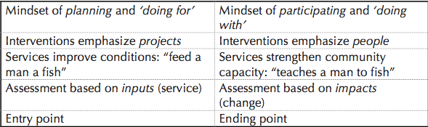
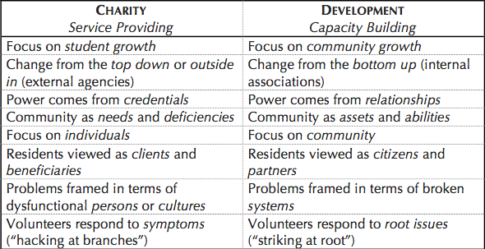
He writes, “The vast majority of ‘institutional’ churches, especially within poor communities, simply do not have the theological breadth, specialized knowledge and skill, whole-community organizing experience, and broader connections to create anything more than ‘service for/to’ projects, oftentimes dependent on foreign monies” (p. 3). He is essentially arguing that churches need to focus on what they are good at: church-based evangelism and church growth.
Table 4.1: Charity vs. Development (Slimbach, 2012, pp. 2-3).

Here it appears that Slimbach takes roots firmly in Jeffrey Sachs’ donor-driven development model. He does not see the capacity for church-based grassroots development—or even any kind of grassroots development—so he resigns to the fact that churches should let the major players in the development world do what they are trained to do: develop communities and seek structural reform. Slimbach points to successful organizations such as Grameen Bank in Bangladesh and Dr. Paul Farmer’s work in Haiti through Partners in Health—both non-church-based initiatives—as examples of best practices in global community development.

To be clear, Slimbach is not arguing that there is no place for the Church in community development. He simply feels that the Church’s main role in development is to develop individuals who then go out into the world and work towards community change—removed from the institutional Church. He writes:

The institutional church shines brightest when it develops the spiritual capital of emerging leaders, and then encourages them to deploy their hope, passion, and talent in non-churchly structures (specialized ‘sodality’ agencies) whose ‘sphere’ it is to understand how to lay sewage lines, establish high-quality schools and health clinics, administer savings co-ops, and the like. Congregations fulfill their vocation in human development when they cultivate among members a vital spirituality that can then drive and sustain socio-economic and even political change. But the complexity of modern urban life requires a base of high-level knowledge and skill. Perhaps this is why so little has been written on church-based slum development: little of it actually exists to write about. (p. 8)

Slimbach distinguishes between the organic Church (i.e. the individual people of God who have God-given passions and talents) and the institutional Church (i.e. the corporate body of believers and structures through which they operate). He argues that individuals can promote social change and community development in all spheres of life—again by working with larger organizations, which have broad capacity and specific skills. However, the institutional Church should not and simply cannot work on a large scale toward these ends.

Oddly enough, Slimbach later quotes and agrees with Matthew Clarke in saying that religious communities like the Church are the largest and most well organized civil institutions in today’s society. For Slimbach, he simply sees that the Church is not making a broad scale impact on communities, so he has thus concluded that it is not possible to do so. However, it seems to be a fallacious argument to claim that something cannot be done because it has not been done yet.

Biblical Arguments
Slimbach also attempts to build a case from Scripture against church-based community development. He appeals to Romans 2:15 (the law is written on the hearts of even unbelievers) and Calvin’s teachings on “common grace” as an appeal for believers to work together with non-faith-based development agencies towards achieving God’s shalom here on earth.

Slimbach later argues, “On several occasions Jesus eagerly welcomed signs of faith among women and men outside the house of Israel, and urged Jews to learn from their example” (p. 9). To Slimbach, this not only appeals to the common grace of humanity, but it also reveals a common ground that we have with all people in working toward the good of our communities.

While his arguments here are sound, they do not seem to be answering the question that he is raising. The central question is whether or not church-based development is practical and/or biblical. But here Slimbach’s main argument from Scripture simply promotes ecumenical partnerships in developing communities—rather than disproving that the Church should be a major player in global community development.

To be fair, Slimbach makes it clear from the beginning that he is merely seeking to complicate the argument for church-based development—not disprove the claim—and his desire is simply to promote further discussion (p.1). But still, his arguments from Scripture are found wanting compared with the vast wealth of biblical teaching that points toward church-based development.

ARGUMENTS FOR CHURCH-BASED DEVELOPMENT

Practical Arguments
In her article The Local Church as the Long-term Presence, Catalyst and Sustainer of Holistic Ministry, Heather Holt pushes back against many of Slimbach’s claims. Her arguments for church-based community development are three-fold.

First, the local church has a long-term presence in the community. This point cannot be overstated. Major NGOs and development organizations seeking to transform communities generally do not have a long-standing presence in every community where they work. In this particular area, the local church actually has greater capacity than the NGOs—the capacity for ongoing presence.

Second, as Slimbach himself admitted, the Church is perhaps the most well organized civil institution in the world. And because this is the case, the Church has the unique ability to organize and mobilize people to promote change in communities.

Maggay (1996) writes, “Wherever the gospel had been preached, closely following it had been a mission hospital or a school, familiar landmarks of the expansion of the cause of Christ” (pp. 56-7). Again, the capacity of the local church in this area is perhaps greater than that of the major donor agencies. It would seem that any large NGO seeking to mobilize and organize communities would be wise to seek the assistance of the local church, rather than the other way around.

Finally, holistic transformation—physical, spiritual, economic, and social—is not sustainable without the presence of a healthy church. In Bussau and Mask’s (2003) Christian Microenterprise Development, they write, “The local church is the primary institution that God has chosen to extend His kingdom. Christian MED programs that wish to build God’s kingdom must serve the local church” (pp. 7-8). It is the Spirit of God working through the body of Christ—the local church—who truly transforms communities in sustainable ways.

Proponents of Sachs’ donor-driven development model put their faith in the big money and highly trained staff of the major NGOs. But as we have already seen, the trillions of dollars spent on development in poor countries over the past half century have mostly produced fruit that did not last—“development” that was not sustainable.

Biblical Arguments
The way we understand the Scripture regarding this topic deeply affects our perspective on this issue. Many of the pastors in Kibera who were not implementing any development initiatives indicated that they felt that the role of the Church was to simply evangelize and provide the community with spiritual nourishment. This perspective appears to be based in the modern worldview, which separates all things into two distinct realms: the spiritual and the physical (Myers, 2011, pp. 30-37). This view also inexplicably ignores the totality of Scripture in which no such distinction is made.

Three major biblical themes stand out in the case for church-based community development.

- Stewardship of the Earth – We need look no further than the first chapter of the Book of Genesis to see God’s plan for mankind as stewards of His creation. In Genesis 1:28, God gives mankind the command to not only fill the earth but to govern it as well. This governance or stewardship can only be meant as charge to maintain and uphold God’s shalom on earth. While sin and the fall of mankind has temporarily frustrated all of creation (Romans 8:20), God has charged us all with the task of working towards restoring God’s peace on the earth.

This was originally a command to all mankind, but surely those who are under the reign and rule of Christ (i.e. God’s children) will have the fullness of God’s grace in working toward this end. Being a good steward of all of creation means particularly looking after those who were created in the image of God and seeking justice and wholeness for those who are oppressed and broken.

- Stewardship of Our Brothers and Neighbors – In Genesis chapter 4, we read about the first murder. The shalom of God has been frustrated by the fall, and Cain kills his brother Abel out of jealousy. God seeks out Cain and questions him about his brother, to which Cain responds, “Am I my brother’s keeper?” (Gen. 4:9). This question echoes throughout the rest of Scripture, and the resounding answer is yes, we are our brother’s keeper.

In Mark 12:31, Jesus answers this question by simply stating that we should love our neighbors as ourselves. Just as we are stewards of all of creation (Gen. 1:28), this emphatically includes our brothers and sisters, our neighbors, and even our enemies (Matt. 5:43-48).

- Stewardship of God’s Kingdom – In Luke 4:18-19, Jesus begins his public ministry by opening the scroll and reading from the Book of Isaiah. Jesus proclaimed that he was anointed by the Spirit of God to proclaim good news to the poor and freedom for the prisoners—recovery of sight for the blind and freedom for those who were oppressed. Jesus was ushering in the kingdom of God, and throughout his ministry he welcomed others to join him in the work of building God’s kingdom.

In 1 Corinthians 12, the Apostle Paul calls the Church the “body of Christ.” He states that all believers (i.e. the Church) have been given unique gifts in order to serve and build God’s kingdom. We have been called to serve alongside Christ in the ministry of restoring creation to God’s shalom.

This again is an issue of stewardship. In Matthew 25:14-30, Jesus tells the parable of the talents. As the story goes, three servants were given a measure of talents by their master. Two of those servants were good stewards of the talents they had been given, and their master rewarded them with even more talents. However, the third servant buried his talent and was not a good steward, so his master took away what he had given the servant and punished him severely.

The message is clear. Those who are in the kingdom of God (i.e. believers) have a responsibility to be stewards of the kingdom, which intrinsically involves promoting God’s shalom here on earth. Many arguments can be made about whether or not the Church today has the capacity for major efforts in community development, but it is clear from Scripture that the Church has the responsibility for making every effort to create sustainable change in their local communities. (And in terms of capacity, the Apostle Paul makes it clear that the Holy Spirit has given the Church the gifts needed to serve God and our neighbors fully.) In doing so, the Church will be promoting the shalom of God here on earth.

V. COMMUNITY CONTEXT

To Kenyans, a mzungu means lots of money.

PASTOR MILO MASUMBA
CALVARY TEMPLE OF KENYA CHURCH, KIBERA

NAIROBI, KENYA
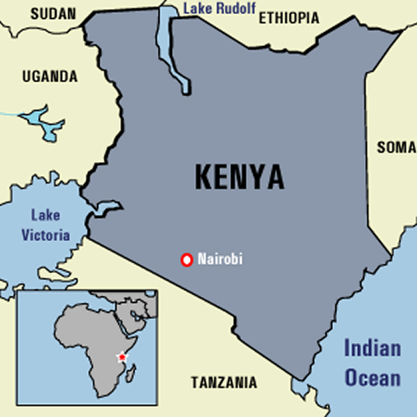
Located in East Africa, Kenya is a rapidly developing country that boasts an emerging global economy. Like so many other African nations, Kenya was colonized by the Europeans. Finally, after a decades-long struggle with the British, Kenya gained independence in 1963.
Figure 5.1: A map of Kenya and its capital city, Nairobi. (Photo credit: www.salongen.de)

Kenya’s capital city of Nairobi was originally founded as a trade post along the Uganda Railway that runs from Mombasa to Kampala. Nairobi has long been one of the more modern cities in all of Africa. A recent boom in economic growth this past decade has led to an increase in the middle and upper classes in Kenya, most of which are located in the capital city. Along with that economic growth, however, has been the growing disparity between the rich and the poor. Informal settlements are popping up all over the city, and it is estimated that 60% of Nairobi’s residents live in slums.

KIBERA SLUM
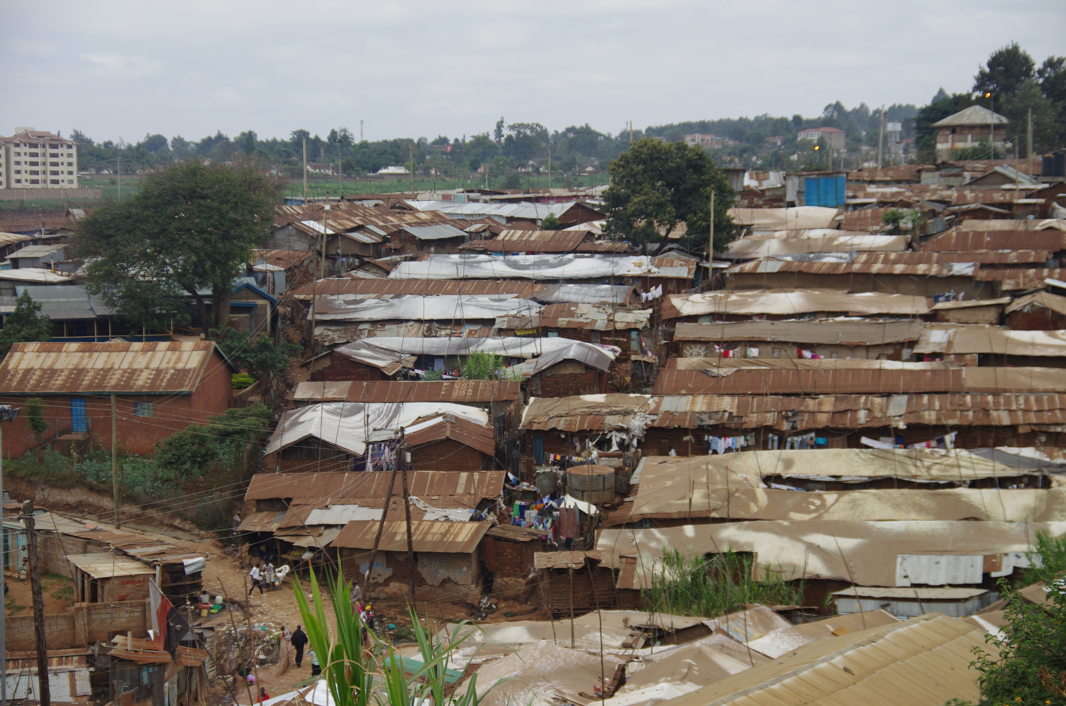
Cast against this backdrop is Kibera, one of Africa’s largest slums. It is estimated that between 800,000 and 1 million people live in Kibera, although it would be nearly impossible to get an accurate number in such an ever-transient community. Kibera’s challenges are many. Poverty in Kibera is rampant. Living conditions are poor, and the dense population provides a breeding ground for bacteria and disease. The youth in Kibera are idle for lack of jobs and opportunities for education.
Figure 5.2: Kibera Slum in Nairobi, Africa's 2nd Largest Slum.
It is a challenging place to live, to say the least.

However, the picture in Kibera is not entirely grim. It is vibrant community with a hard-working labor force. It is also a place that boasts a strong Christian presence and community. It is this Christian community that is the target of this research.

More specifically, this study targets pastors of local churches in Kibera to determine what steps these churches are taking to develop the slum at the grassroots level. These local pastors have estimated that there are between 400-500 churches in the slum. This study will investigate 42 of these slum churches—representing approximately 8-10% of the churches in Kibera.

VI. METHODS

The people must accept that Kibera belongs to them.

PASTOR MICHAEL NYANGA
JESUS PRAISE AND WORSHIP CHURCH, KIBERA

RESEARCH BIASES
Before turning to methodology, it is important to first note several biases I as the researcher am bringing into the research process. First, I am entering into the research as a devoted follower of Jesus Christ. I believe in the truth of God’s Word, the Bible. I also believe that all men are created in the image of God and as such are loved and valued by God who created them and all things. This bias toward my Christian faith has surely shaped the way I have perceived the collected data.

I am also biased toward a particular framework of community development, which is shaped by both theory and, again, theology. It is my belief that communities should be transformed from the inside out, and I believe that this should happen primarily through the local church. This topic has already been discussed in depth in section 4.

RESEARCH QUESTIONS
This project is rooted in several research questions, around which this study has been designed. The central research question is: Can slum churches in Kibera develop their own communities? With this focus in mind, pastors of churches in Kibera have been targeted in order to determine the variables related to church-based slum development in Kibera. Two follow-up questions to the central question are: 1) What efforts, if any, are churches in Kibera currently making to develop the community? and 2) What are the challenges or hindrances to doing church-based grassroots development in Kibera?

Perhaps another bias entering the research process was an assumption that the churches were doing very little or nothing at all in terms of development initiatives. This project was designed to draw out the truth and the local perspectives from slum pastors regarding these issues.

PARTNER ORGANIZATION
My Father’s House Ministry
Finding the right partner organization for this project proved a difficult task. Initial arrangements were made with a local NGO that partners with slum churches, but those plans fell through. This was for the best, however, as the door opened to partner with My Father’s House Ministry (MFH) in Kibera. MFH operates as a local church in Kibera, but they also do leadership and pastoral training locally as well as throughout much of Kenya.

An initial meeting was held with Pastor Mike Aloo of MFH in order to assess whether this might be a good partnership for the project. MFH was assessed on the basis of six criteria:

- Legitimacy – MFH is a very well respected local organization and church. Pastors and other community members from all over Kibera meet daily (Monday-Friday) at MFH for discipleship, leadership training, and pastoral support. Pastor Mike also has very good standing as a leader in the community, and he—along with the other pastors at MFH—are respected leaders and members of the community.
- Problem-focused – MFH focuses significantly on the problem of lack of good leadership and pastoral training in Kibera and throughout Kenya. MFH oversees a network of churches throughout Kenya and in Kibera serves as a hub for leadership and pastoral training.
- Exemplary – Pastors Mike Aloo, Boyd Dennis, and Evans Kiambi have several decades of experience as pastors and developers of leaders. They all live in Kibera with their families and understand well the realities on the ground for pastors in Kibera. MFH stands out in Kibera as an effective and exemplary organization for training leaders.
- Public – MFH works with churches across Kenya that cross tribal lines. The staff at MFH also comes from different tribes, and they work with a diverse cross-section of community residents from different backgrounds.
- Participatory – MFH holds conferences and trainings that directly address issues of need raised by pastors within the communities where they work. Again, the pastors themselves are also a part of the community in Kibera and understand the needs on the ground. They are very participatory.
- Supervised – MFH does have bilingual national staff who are willing and able to provide supervision and feedback for outside researchers. Pastor Mike agreed to supervise the research and serve as the primary research assistant on the field. This was the best-case scenario for this study, as Pastor Mike is very well networked with pastors throughout the slum and was able to offer special insight throughout the research process.

A PARTICIPATORY APPROACH
The goal of this project is ultimately to benefit the research participants and the local community in Kibera. With this end in mind, this research project was conducted with a participatory-action approach.

The first step in this participatory approach was to identify a host organization and agree on a mutually beneficial topic for research. As previously stated, the search for a host organization led to My Father’s House Ministry (MFH) in Kibera—a local ministry that trains and equips pastors and church leaders in Kibera and throughout Kenya. After a meeting with Pastor Mike Aloo from MFH, it was quickly agreed that it would be useful and beneficial to conduct an in-depth study on current church-based development efforts in Kibera.

As a part of this process, both local and global literature on this topic was organized and researched. While continuing with this secondary research, first-hand interviews with pastors in Kibera were conducted. These interviews were semi-structured, with a set of 10 questions (See Appendix 2 for interview questions). However, the participants were able and encouraged to share stories and add additional information beyond the set of questions. The data collected included field notes (i.e. detailed summaries of the interviews), as well as audio recordings of the interviews. The interviews generally lasted between 30 minutes and 1 hour. Adding in time for organizing field notes and analyzing the audio recordings, each interview included up to 2 hours of work. The total time spent doing fieldwork was around 80 hours.

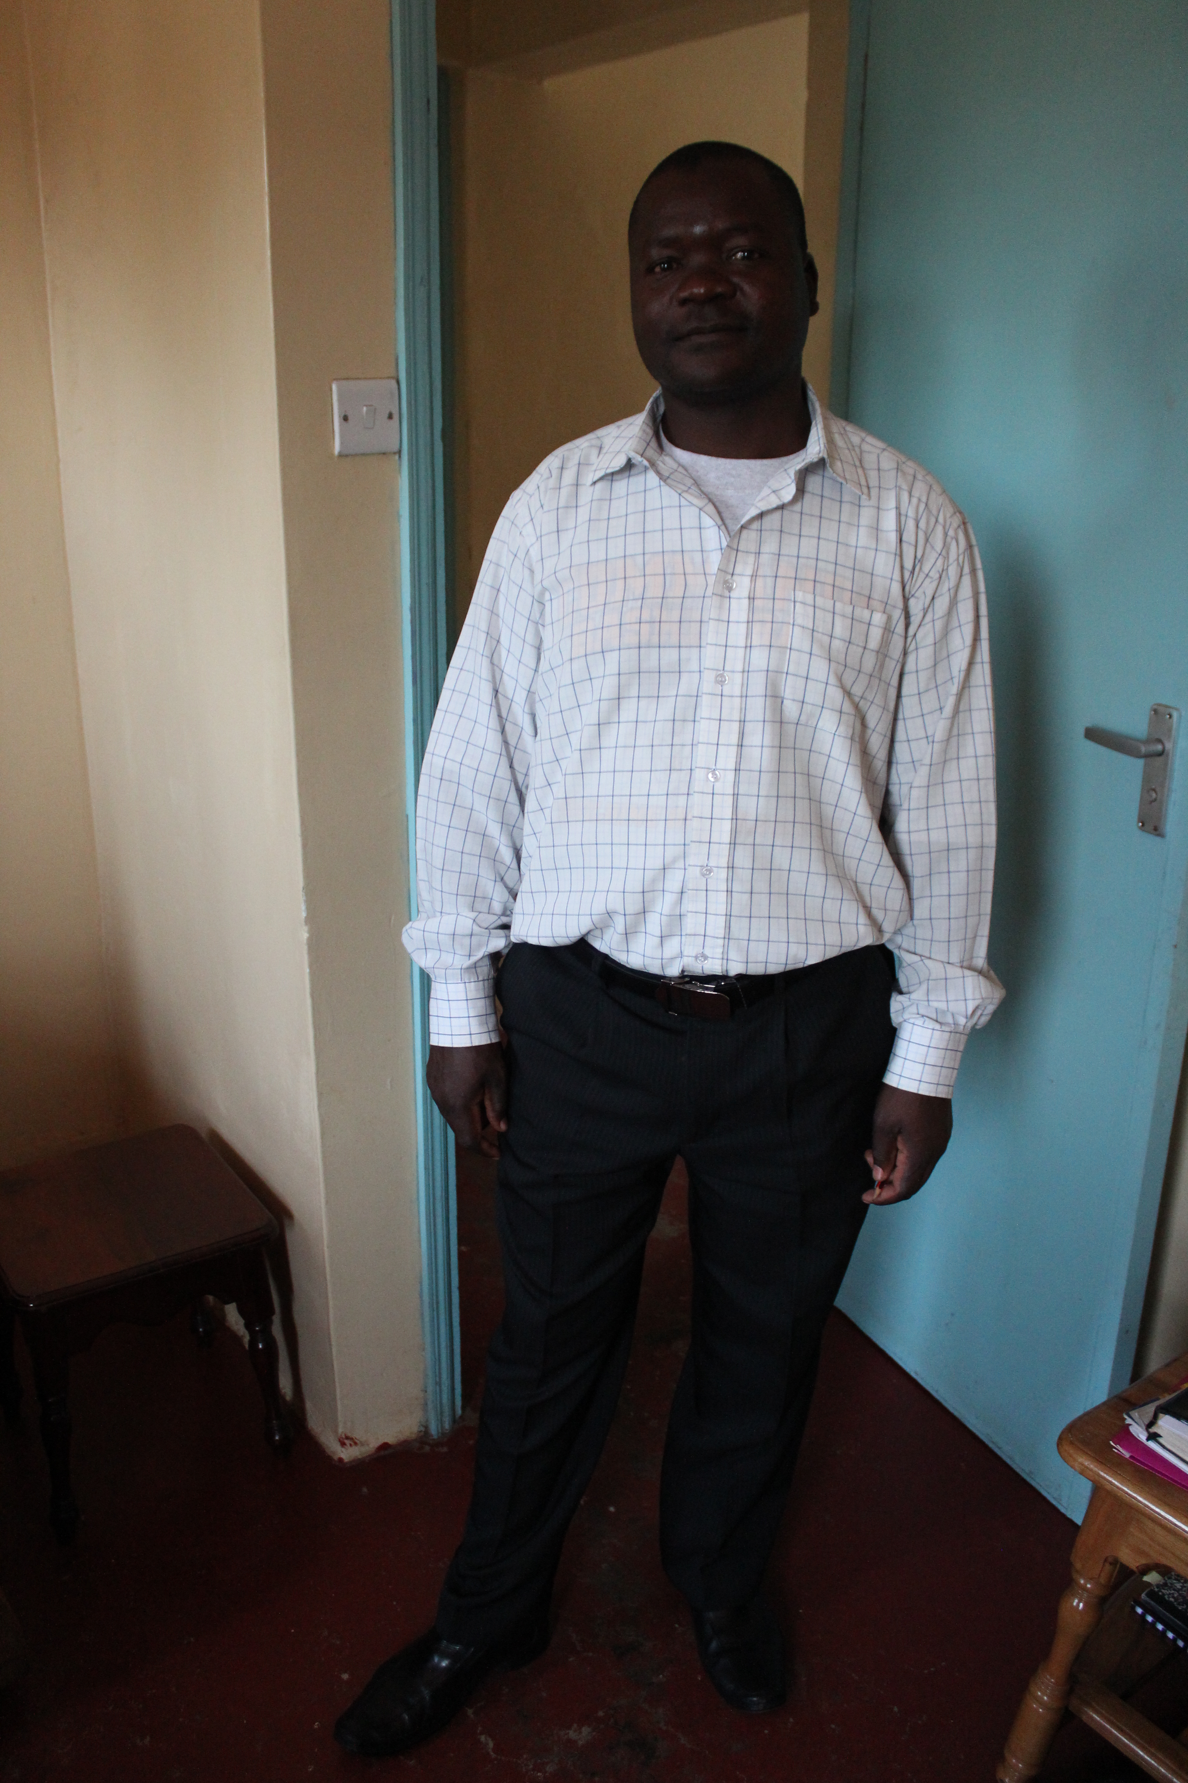
This study has clear and immediate benefits for both the host organization and the community. For MFH, it allows them to better understand the on-going ministry in the slum and to perhaps get a better perspective of the strengths, weaknesses, and challenges of the churches in Kibera. And for the community, this study gives the pastors and their local churches a broader perspective of the work they are doing, while offering some action steps that might be taken in the future to improve the work they are doing.
Figure 6.1: Pastor Mike Aloo from My Father's House Ministry in Kibera. Pastor Mike served as the research assistant for this project.

The goal is that these leaders might then brainstorm and collaborate together for a long-term plan of how they might further develop their community together. In order to complete the participatory-action cycle, a follow-up meeting was conducted with MFH and the local church leaders and pastors to report back on the findings and conclusions of the research. This report back was intended to serve as a catalyst and spark ongoing discussion and collaboration among the pastors—a conversation that hopefully might eventually lead to action in the local church. I helped facilitate this discussion during my report back, but ultimately it has been turned over to these leaders to take control and lead the discussion going forward.

SAMPLE SELECTION
Pastor Mike, the research assistant, was responsible for selecting the pastors to participate in this study. As previously mentioned, Pastor Mike is well networked with pastors and church leaders in Kibera, and he proved invaluable to the research process.

Pastor Mike selected pastors for this study based on several criteria. The research was conducted over a 6-week period in May and June of this year. Participating pastors were first of all available to participate during this time frame and the selected days for research. The pastors also all had to indicate a willingness to participate.

Pastor Mike also tried his best to seek out a variety of pastors from different backgrounds, tribes, and church denominations. An effort was made to also select pastors from many villages throughout Kibera in order to get a good sample of the entire population. The forty-two churches in this study were spread throughout 10 of the 13 urban villages in Kibera.

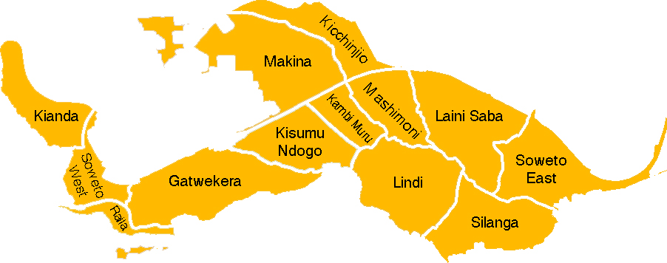
Figure 6.2: A current map of the 13 villages in Kibera. Churches in this study represented 10 of these 13 villages.

DATA COLLECTION
Interviews
The data for this research was collected solely through one-on-one interviews with pastors of churches in Kibera. In total, 42 pastors were interviewed over 12 days of research spread over nearly 6 weeks from May 15 – June 22 of 2014. The sample selection of pastors were asked 11 questions specific to the topic of church-based community development (See Appendix 2), and they were encouraged to share stories from their experience with grassroots, church-based development.

These interviews were recorded and detailed field notes were taken throughout the entire research process. These field notes were later organized and analyzed to produce the results of this study.

ETHICAL CONSIDERATIONS

The entire research process was conducted with willing consent of all parties involved. Each pastor was told preceding the interviews that this research was being done for educational purposes. It was clearly stated that the results of the research would not be used for profit of any kind, other than for the completion of an educational degree.

Each pastor was also asked prior to the interview for verbal permission to record the interviews. After explaining the purpose of recording, all of the pastors willingly complied with this request.

Each pastor also consented to full permission for their stories to be used in this final report of the research. Had there been a case of any sensitive information, certain names would have been omitted in this study. The names used in this report were used by verbal consent and the researcher’s discretion.

OUTCOMES
First and foremost, this research has culminated in this final project for the completion of the MA in Transformational Urban Leadership degree through Azusa Pacific University. To the best of the researcher’s ability, it is a representation of personal growth as a student-learner both academically and pragmatically throughout this program.

Secondly, this final project has been summarized and presented back to the host organization and participants in the study—in this case pastors in Kibera slum. This presentation allowed the community to critique, challenge, and affirm the research findings.

Finally, the goal of this study is to identify real actions/processes by which the church in Kibera is working toward developing the community. This will help inform the global discussion about grassroots church-based community development. It will also result in a discussion with a group of pastors in Kibera, who can begin dreaming about how they might partner together to do more large-scale development of the community. The hope is that partnerships are formed and further outcomes in the community are realized in the months and years to come through these partnerships.

VII. DESCRIPTION OF RESEARCH FINDINGS

As a pastor,
when you are not well empowered financially,
people mock you.
‘Where is your God?’ they ask.

PASTOR JULIUS LUGALIA MABOLEO CHENGO
LIBERATION MANDATE CHURCH, KIBERA

In this section, raw data collected from 42 participating pastors in Kibera is presented. This data is intended to answer the research question: Can slum churches in Kibera develop their own communities?

KEY DEMOGRAPHICS AND FINDINGS
Research Participant Demographics:

TABLE 7.1 – Denominational Demographics of Surveyed Churches

# of Participating Pastors/Churches | Avg. Church Age | Avg. Church Size | % of Pastors Living in Kibera
42 | 8 years | 59 members | 98%
TABLE 7.2 – Basic Demographic Data of Participating Churches/Pastors

The pastors were questioned about whether or not they receive a salary from their churches. Only 5% of the pastors indicated that they receive a full salary from their church. The following chart represents the breakdown of pastors who do and do not receive some salary from their churches:

TABLE 7.3: Salaried vs. Non-Salaries Pastors

Each pastor was asked to share the greatest needs and challenges that the community of Kibera faces, as well as the greatest resources and assets in the community. The following tables indicate the most common responses to these questions:

Most Common Needs/Challenges in Kibera | % of Pastors
1. Education | 57%
2. Poverty | 55%
3. Jobs/Unemployment/Idleness | 48%
4. Low Income | 43%
5. Lack of Food | 38%
6. Sickness/Disease/HIV | 31%
7. Violence/Abuse/Insecurity | 26%
7. Sanitation/Sewage | 26%
9. Lack of Access to Healthcare | 21%
10. Lack of Clean Water | 17%
10. Inadequate Housing/Shelter | 17%
10. Ignorance | 17%
TABLE 7.4 – Interview Data: Needs/Challenges in Kibera

Most Common Resources/Assets in Kibera | % of Pastors
1. Close Community/Care for One Another | 38%
2. Skilled/Hardworking Labor Force | 33%
3. Word of God | 24%
4. High Population/People Resources | 19%
4. Peace | 19%
6. Small Businesses | 17%
7. People Desire Empowerment | 14%
7. Community Participation | 14%
9. NGOs/CBOs | 12%
10. Diversity | 10%
TABLE 7.5 – Interview Data: Resources/Assets in Kibera

The pastors were also asked about partnerships their churches had within the community of Kibera. The following chart represents this data:

Community Partnerships in Kibera for Surveyed Churches | % of Pastors/Churches
Involvement in a Pastor’s Network | 52%
Partnering with Other Churches for Community Development | 33%
Partnering with NGOs | 19%
TABLE 7.6 – Community Partnerships for Surveyed Churches

The pastors were also asked a series of questions about the different kinds of development work their churches are doing. The following charts represent this data:

TABLE 7.7 - % of Development Work Among Surveyed Churches

Different Types of Development Work Among Surveyed Churches | % of Churches
Economic Development | 71%
Business Training/IGAs | 43%
Savings Cooperatives (SACCOs) | 38%
Rotating Savings Groups (ROSCAs) | 33%
Microfinance | 19%
Church-Based Schools | 40%
Church-Based Health Clinics/Health Education | 21%
TABLE 7.8 – Different Types of Development Work Among Surveyed Churches

Finally, 17 of the pastors were asked to share what methods they felt were needed in order to develop Kibera. The following chart represents this data:

Most Common Methods for Developing Kibera | % of Pastors
1. Start Schools/More Education | 41%
2. Technical/Business Training and Empowerment | 41%
3. Pastors Need Empowerment/Training | 35%
4. Development Must Happen Through Local Church | 18%
4. Government Assistance Needed | 18%
4. Job Creation | 18%
7. Funding for Small Business | 12%
7. More Hospitals | 12%
7. More Support Organizations/NGOs/CBOs | 12%
7. Development Starts From the Inside | 12%
7. Land Ownership | 12%
TABLE 7.9 – Interview Data: Methods for Developing Kibera

EMERGING THEMES

After collecting and organizing the data, several key themes emerged from the data. These themes will be discussed briefly in this section.

Small and Young Churches
Two notable themes on the demographics of the surveyed churches were the size and age of the churches. These churches were relatively small, with an average membership of 59 adults. Of the 42 surveyed churches, 39 of them had 100 or fewer members. Only two of the churches had more than 200 members, and just one church had 300+ members. The lack of space and facilities in Kibera to accommodate larger congregations likely plays a significant role in church size.

The surveyed churches were also very young, with an average age of 8 years. Thirteen of the 42 churches were 3 years old or younger, while only 5 of the churches were 15 years or older. The age and size of these churches surely has a large impact on their capacity for community development initiatives.

Education
Pastors in Kibera see education as a primary tool for developing the slum, and they are doing something about it. There are not nearly enough "free" public primary schools in Kibera, so the churches are stepping up and starting their own small church-based private schools. Of the 42 churches, 17 of them (40%) have started schools. This is significant.

Economic Development
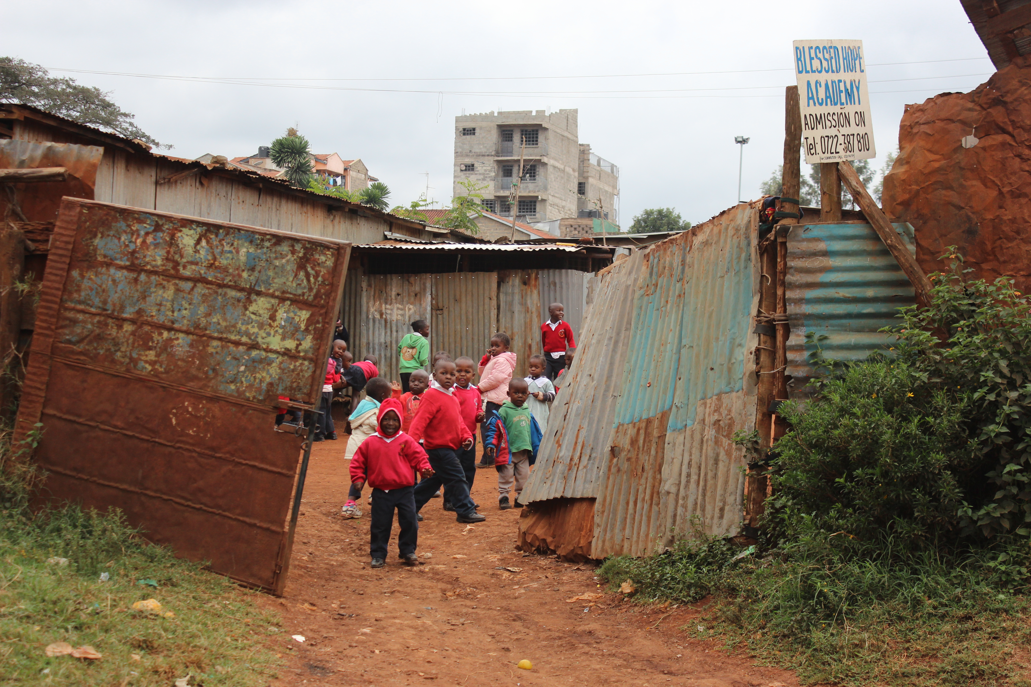
The pastors also view lack of jobs/income as a major threat to development of Kibera. Because of this, of the 42 churches, 30 of them (71%) are operating some form of economic development activities through the local church. These involve microfinance initiatives, savings cooperative groups (SACCOs), merry-go-round savings groups (ROSCAs), or other training in income generating activities. Again, this is a significant theme in the data.
Figure 7.1: Children playing in the courtyard of Blessed Hope Academy, a small church-based school in Kibera.

Poor Churches
Time and again, the pastors indicated that their churches are struggling financially. The best indicator of this theme is the fact that 79% of the surveyed pastors receive zero salary from their churches. In fact, many of these pastors shared that they help support the ministry of the church from their own pockets, rather than the other way around.

(Lack of) Church Partnerships
Despite the overwhelming amount of development work being initiated by the slum churches, there seems to be a lack of real partnerships among churches. Simply put, they are not working together. Among the pastors interviewed, 22 of the 42 (52%) indicated that they have some partnership with other pastors/churches, but in practice this most often looks like pastoral fellowships with no real working partnership in development efforts. Only 14 of the churches (33%) are partnering together in any real development initiatives.

Negative Perspective. The pastors were asked two reciprocal questions, namely: 1) What are the needs/challenges in Kibera? and 2) What are the resources/assets in Kibera? Overwhelmingly, the pastors spent much more time and were quicker to answer about the needs/challenges in the community. Some of the pastors could not even think of a single positive thing to say about the community. This negative perspective on the community undoubtedly affects the prospects of developing the community through the local church in any significant way.

These themes have led to one significant broader theme: Church-based community development is possible (and currently taking place) among urban poor churches in Kibera. More could undoubtedly be done through more organization and cooperation of these churches and their leaders, as well as a more positive outlook on the slum community itself. But nevertheless, development is happening slowly on the grassroots level. And that is certainly significant.

SUMMARY
The research data collected for this study has revealed some significant themes. Though the churches in Kibera are young, small, and undoubtedly poor, they are doing much with the little that they have. The majority of these churches (76%) are active in some form of community development initiative. They are starting schools (40%), implementing economic development groups and programs (71%), and focusing on healthcare (21%).

At the same time, these churches are not partnering together well. They are often starting development work independently of their neighboring churches. Many of the pastors also struggle with a negative perspective of their community. These factors hinder the further growth of church-based community development in Kibera.
VIII. RESEARCH ANALYSIS

Education is critical.
Once people are empowered,
they will come out of poverty.

PASTOR GEORGE OWICH
NEW LIFE REVIVAL CHURCH, KIBERA

From the research data described in the previous section, it is clear that the majority of churches in Kibera have both the capacity for implementing grassroots church-based community development, as well as the motivation for doing so. The results of this study are staggering and definitive: slum churches are doing grassroots community development at a significant rate.

In this section, we will briefly analyze the implications of the research data, as well as variables that affect the ongoing church-based development of Kibera.

IMPLICATIONS OF RESEARCH FINDINGS
Making Something Out of Nothing
Time and again, the pastors in Kibera lamented that they have very few resources with which to develop their communities. For nearly every pastor, it was much easier to list the challenges and needs in the slum than to think of resources and assets in the community. This is natural and is to be expected in a slum like Kibera. One would surely anticipate from these kind of statements that the churches were accomplishing very little, if anything, in terms of real community development. This was not the case, however.

The data reveals definitively that the churches in Kibera are incredible stewards of their resources. With the little that they have, they are doing great things in the community.

Prioritizing Greatest Development Needs
One of the most beautiful things about the data from this study is that it reveals that the pastors have identified the greatest needs in the community and are striving to meet those specific needs. The church-based development efforts in Kibera are not happening haphazardly.

The top three needs/challenges in the community, as intimated by the pastors, are education, poverty, and jobs. The churches have clearly made deliberate efforts to develop the community in these three areas.

To deal with the need for education in the slum, many of the churches (40% of those surveyed) have taken it upon themselves to start community schools in the slum. This is significant on many levels. First, it directly addresses the need for more education. With only five government schools in or near Kibera, there simply are not enough schools to accommodate all of the children in the slum. The churches in Kibera are making a significant impact on the education of the next generation of children in Kibera by directly providing that education.

Starting schools also has two other benefits for the development of the community. By starting schools, these churches are directly addressing the issues of poverty and joblessness by creating jobs for teachers and school managers. And, in the cases where the schools are able to make a small profit, the churches are able to help fund their ministries and other development efforts. This is a brilliant development plan, and it only further proves that the churches understand their communities and are directly addressing the most pressing needs.

In the same way, an overwhelming amount of churches have begun initiatives for the economic development of their communities. The data shows that 71% of the surveyed churches are doing some kind of economic development activities—from small business training to savings cooperative and microfinance projects. Again, these churches are recognizing the need for jobs and a steady income to fight the cycle of poverty that is so prevalent in the slum, and they are attacking this problem directly. The significance of this cannot be overstated.

Inside-Out Development Works
We have seen how major voices in the development world—such as Jeffrey Sachs of the UN Millennium Goals—have placed the burden of global development on major donor-based initiatives. Even from a Christian perspective, Richard Slimbach has argued that perhaps the local church—particularly in urban poor communities—does not have the capacity for doing broad scale development. This research strongly suggests an alternate reality at the grassroots level.

Perhaps Slimbach would argue that all of the “development” efforts of these churches are merely small seed projects, and he would not be wrong in making such an argument. However, if enough seeds are planted, a mighty forest can be grown with time. The capacity of these churches in their development efforts should not be viewed on an individual basis. Rather, by viewing the Church in Kibera collectively, one can see the immense potential for transforming the community from the inside out. The key here is partnerships, which will be addressed extensively now.

VARIABLES WHICH AFFECT CHURCH-BASED DEVELOPMENT
Partnerships
The most significant variable affecting church-based community development in Kibera is the lack of real partnerships. Only 33% of the churches surveyed could point to any kind of small partnership with other churches in development efforts. This lack of real collaboration and unity among the churches in Kibera is greatly hindering the immense potential for church-based development and community transformation.

This issue was discussed often with the pastors in their interviews, and it became abundantly clear that there are several factors that hinder church partnerships towards community development.

One pastor indicated that he had been working on a development project with another church when the other pastor ran off with the money and “stole” 15 members from that pastor’s church. After having been burned like that, the pastor being interviewed seemed extremely hesitant to consider partnering with other churches in the future. This variable is perhaps best summarized by the word corruption. Kenya is one of the most corrupt countries in the world—from the government all the way down to the common man—and the Church in Kenya is unfortunately not exempt from issues of corruption. If the pastors in Kibera cannot learn to trust one another, it will be difficult to see healthy partnerships developed.

Another unfortunate barrier to church partnerships in Kibera is that some of the pastors seem to be more focused on building their own “kingdoms” than working with others and building something together. It is significant that 74% of the churches surveyed are independent, non-denominational churches. Many of the pastors in Kibera have very little accountability structures in place and are used to operating independently. This mentality will have to change for networks of church partnerships to be established.

Lack of Resources
While Sachs and Slimbach have perhaps gone too far in their assessment of the lack of capacity in grassroots development movements, they are not wrong that these initiatives often lack the resources to accomplish their goals in the community. This is one of the more glaring variables negatively affecting church-based development in Kibera. Many of the churches are doing the best they can with the limited resources they have, but their capacity is severely limited by lack of resources—most notably finances to implement their development projects. The sobering reality is that without some outside help, these grassroots initiatives will take a long time to produce wide scale, sustainable development in Kibera. At the same time, we must pause and consider that any development that is sustainable will take time to give birth and grow.

Handout Mentality
A significant negative side effect to the donor-driven model of development endorsed by Sachs is the tendency to create systems of dependency—in this case poor communities like Kibera depending on foreign NGOs to swoop in and transform their communities. This lack of community ownership and participation has very damaging long-term effects, and churches in slum communities are not immune to these effects.

While the majority of the churches surveyed for this study are doing some kind of development activities, there is also a sense that many of these pastors are longing for the day when they might get donor funding and assistance. They are hopeful that someday their handout might come. This prevailing attitude represents a barrier to the Church in Kibera taking a central role in the discussion and implementation of community development in the slum.

Essentially, it seems that these pastors suffer from an inferiority complex. They see the workers for the major NGOs driving all over Nairobi in their expensive Land Rovers, and they feel like they will never be able to make an impact in their communities like these well-funded outside organizations. Until this mentality is changed, it will be difficult for the Church in Kibera to move to another level and begin doing broad scale development of the slum.

IX. RECOMMENDATIONS

I’m looking for ministry partners who have the same heart.
I cannot do this work alone.

PASTOR WASHINGTON OMONDI
END TIME REVIVAL MISSION, KIBERA

This research is completely meaningless if it does not produce actions on the ground level. The final step of the participatory-action research process is to hand ownership of the results and ongoing action steps back to the local community. In an effort to do just that, the findings from this study were reported back to a group of 40 pastors and church leaders in Kibera. The following action steps were suggested as a way forward for the churches in Kibera.

SHORT-TERM ACTION STEPS
Awareness of the Resources and Capacity for Grassroots Development in Kibera
This study intentionally forced the pastors to think about the resources already available in the community. The very first step in moving toward transformational development is to stop focusing on all the barriers to development and start seeing the positive aspects of the community. This positive outlook provides one of the basic building blocks for future development initiatives.

Awareness of Other Church-Based Development Initiatives
It became clear throughout the research process that many of the pastors in Kibera are ignorant of the development efforts of other churches around them. The first step toward developing long-term, sustainable partnerships is for the churches in Kibera to have an understanding of what other initiatives are being attempted around them. With this new awareness, the churches may find that there are many opportunities for partnering together.

This was one of the motivators behind the report back to the pastors. At this presentation, these pastors were able to all sit together in the same room and hear about the similar work they are all independently doing. The hope is that this new awareness might spark new discussions about ways in which the churches can begin working together.

Starting the Conversation
The natural follow-up from this new awareness is that a conversation might spring up about the potential of some of these churches working together. This research can be considered a success if it simply gets the conversation started—which appeared to be the case at the report back.

Developing Partnerships
Finally, the biggest short-term action step is to begin forming small networks of churches who feel they have similar vision and can begin working together—even if just on a small seed project. The trust built in even a small partnership will be crucial to the long-term plan for sustainable and wide scale church-based community development.

LONG-TERM ACTION STEPS
A Network of Church Partnerships
The long-term action plan is very straightforward. The goal is that these initial actions of creating awareness, opening a community dialogue, and forming small partnerships for seed projects might grow into a large network or web of networks of churches in Kibera. These churches can build off the small-scale development efforts that they are already doing in order to impact social change on a greater scale than ever before.

The capacity is already there. The great hurdle will be the pastors coming to the realization that their churches can do so much more together than they are currently doing alone. And by accomplishing such a large task from within the community, these churches will be able to own the results. They will be able to say, “Our community did this, together.” That ownership is something that the donor-driven model cannot offer the slum communities. And that is something worth striving for.

X. RESEARCH SIGNIFICANCE

Before we go to heaven, we are here to eat.

PASTOR JOSHUA ORWA
CROSS MESSENGER MINISTRIES, KIBERA

This section identifies the significance of the research findings. This includes the contributions of this study to the broader field of research, as well as its contribution to the host organization and local community. Finally, this section concludes with an assessment of the limitations of this research and what further research might be needed in the future.

CONTRIBUTIONS TO THE FIELD OF RESEARCH
It is possible—perhaps probable—that this study is unique in the scope of data retrieved directly from pastors in Kibera about their own development efforts. No previous research was found which employed this participatory-action approach to studying church-based development efforts in Kibera. As mentioned previously in the literature review, there was one study by Muvengi—a doctoral dissertation—that had a very similar research focus. And in fact this study reinforces many of the same conclusions of that research. However, this study took on a much more personal nature. In this case, the researcher spent more than a year living and learning in Kibera before conducting any field research. The approach of interviewing the pastors directly in their churches within the community also furthered this personal approach.

The results of this study also contribute to the global conversation regarding the capacity for inside-out development within poor communities. While the collected data represents a small sample of grassroots church-based development efforts in the world’s slums today, the results quite clearly reveal that slum churches have the capacity for developing their own communities in significant ways.

CONTRIBUTIONS TO THE HOST ORGANIZATION AND COMMUNITY
My Father’s House Ministry in Kibera focuses primarily on developing church leaders in Kibera and throughout Kenya. This research has helped inform MFH on the challenges and realities faced on the ground by so many of the pastors in the slum. This research will likely help MFH further develop leadership training that is specific to the unique challenges and opportunities slum pastors face regularly.

At the same time, this research empowers these pastors by giving them a voice. Their blood, sweat, and tears are all over the pages of this report. This research gives validity and recognition for the selfless work they are doing to transform their communities from the inside out. This research has also sparked a conversation among these pastors, which has the potential to spark a movement of church partnerships in Kibera. This would be the greatest contribution of this research if the pastors are moved to action in this way.

LIMITATIONS OF RESEARCH
This research was limited by a number of factors. The allotted time for field research limited the potential scope of the research. While 42 churches surveyed represents a somewhat significant sample size, it cannot be used to represent the entire community.

Likewise, the pastors surveyed for this study were chosen based on the limitation of the connections Pastor Mike had in the community in Kibera. While Pastor Mike is perhaps one of the most networked church leaders in Kibera, it is safe to assume that working with another organization and research assistant would have led to a different sample group. Nevertheless, it is highly unlikely that a different sample group would have produced significantly different results from this study. In fact, after hearing the results of the research, the pastors themselves validated them as a representative sample.

ADDITIONAL RESEARCH NEEDED
This study represents simply the tip of the iceberg of needed research on church-based community development in Kibera. The most pressing research that is needed is a follow-up to this study. It would be helpful to track the progressions of the pastors as they begin to mobilize networks of churches for community development initiatives. Perhaps a pertinent research question would be: What barriers are churches in Kibera facing as they begin development networks? Another important question for research might be: How are the church-based development networks in Kibera transforming their communities? Such a study could build on this one and serve as a contrast between independent church-based development initiatives and cooperative church-based development efforts.

XI. CONCLUSION

With the little we have, you can see what we have done.

PASTOR JOSEPH CHALLO KIOKO
CHRISTIAN HARVEST, KIBERA

As the global debate between donor-driven and community-driven development rages on, this study concludes strongly in favor of inside-out development. The development effort of the churches in Kibera is perhaps the best-kept secret in the slum. While donor agencies and major NGOs get all the hype and attention in Kibera, there is a subtle but powerful undercurrent sweeping through the slum of grassroots development work through the local churches. The impact can be seen and felt in the crucial areas of education, economic development, and healthcare.

What is perhaps most significant about these research findings is that the Church in Kibera is doing so much, but it has still not yet come close to reaching its capacity for community development. At the current time, most of the church-based development efforts in Kibera are happening independently. Simply put, the churches have not yet learned how to work together. This is the crucial next step towards the grassroots development of the slum, and its potential impact on the community almost knows no limits.

The goal of this study is to move the churches in Kibera to further action. The research has long been finished, the data has been analyzed over and over, and it has finally been handed back to the community in completion of the participatory-action cycle. It is now up to the churches in Kibera. If the churches can learn to share resources, to share ideas, and to work together, then the future is looking bright for Kibera slum.

Bibliography

Barker, A. (Sept. 2006). Transforming slums: Will we hear the cries of one billion people before it is too late? Lausanne World Pulse. Retrieved from http://www.lausanneworldpulse.com/themedarticles.php/474/09-2006?pg=all
Bussau, D. and Mask, R. (2003). Christian microenterprise development: An introduction. Eugene, OR: Regnum Books.

Cronin, V., & Guthrie, P. (June, 2011). Alternative approaches to slum upgrading in Kibera, Nairobi. Urban Design and Planning, 164(DP2), 129-139. Retrieved from https://www.academia.edu/633862/Alternative_approaches_to_slum_upgrading_in_Kibera_Nairobi

Deacon, G. (2012). Pentecostalism and development in Kibera informal settlement, Nairobi. Development in Practice, 22(5-6). 663-674. http:/ / dx.doi.org/ 10.1080/ 09614524.2012.685874

Easterly, W. (2006). The white man’s burden: Why the West’s efforts to aid the rest have done so much ill and so little good. New York: Penguin Press.

Evangelical for Social Action. (2014). Holistic Ministry Defined. Retrieved from http://www.evangelicalsforsocialaction.org/holistic-ministry/holisticministrydefined/
Garau, P., Sclar, E.D., & Carolini, G.Y. (2005). UN millennium project task force on improving the lives of slum dwellers. Retrieved from http://www.unmillenniumproject.org/documents/Slumdwellers-complete.pdf

Grigg, V. (2004) Companion to the poor: Christ in the urban slums. Waynesboro, GA: Authentic Media.

Higgins, A. (2013, Feb. 24). Kibera: Nairobi’s biggest slum challenges the development narrative. Good Magazine. Retrieved from http://magazine.good.is/articles/kibera-nairobi-s-biggest-slum-challenges-the-development-narrative

Holt, H. (2013, July 18). The local church as the long-term presence, catalyst and sustainer of holistic ministry. William Carey International Development Journal. Retrieved from http://www.wciujournal.org/blog/post/the-local-church-as-the-long-term-presence-catalyst-and-sustainer

Kelley, S.P. (2008). Subsidiarity and global poverty: Development from below upwards. Vincentian Heritage Journal, 28(2), 151-165. Retrieved from http://via.library.depaul.edu/cgi/viewcontent.cgi?article=1328&context=vhj

Maggay, M. P. (1996). Transforming society. Eugene, OR: Wipf and Stock.

Mulcahy, M., & Chu, M. (2007). Kibera Soweto East: A case study in slum upgrading. Retrieved from http://www.design.upenn.edu/new/cplan/02b_KiberaMulcahy.pdf

Muvengi, D.M. (2011). Poverty, church, and development in Kenya: A case study of Kibera slums in Nairobi. (Doctoral dissertation). Retrieved from http://dspace.nwu.ac.za/bitstream/handle/10394/4625/Muvengi_DM.pdf?sequence=2

Myers, B.L. (2011). Walking with the poor: Principles and practices of transformational development [Nook version]. Retrieved from Barnesandnoble.com

Sachs, J.D. (2005). The end of poverty: Economic possibilities for our time. New York: Penguin Press.

Sesana, R.K. (2014). Kibera: The correct numbers. News from Africa. Retrieved from http://www.newsfromafrica.org/newsfromafrica/articles/art_11595.html

Shinkle, K. (April 11, 2008). Jeffrey Sachs on beating global poverty: The Colombia economist says it can be done with little investment. US News. Retrieved from http://money.usnews.com/money/business-economy/articles/2008/04/11/jeffery-sachs-on-beating-global-poverty

Slimbach, R. (December, 2012). Local churches and development: How ‘central’ are they? William Carey International University Development Journal. Retrieved from http://www.wciujournal.org/uploads/files/Slimbach%20Church%20and%20Development.pdf

Taylor, M. (2011). Strengthening the voice of the poor: Faith-based organizations’ engagement in policy consultation processes in Nigeria and Tanzania. Religion and Development Research Programme. Retrieved from http://www.religionsanddevelopment.org/files/resourcesmodule/@random454f80f60b3f4/1300096018_summary_paper_61.pdf

The Urban Advance. (1995). The Urban Advance: A concluding report. Retrieved from http://www.transformational-development.org/ministry/transdev2.nsf/2EC8A680B31C145388256F6C00537660/$file/The%20Urban%20Advance%20-%20A%20Concluding%20Report.pdf

Appendix 1: Acknowledgements

I would first like to thank my wife, Kelsey, for her abundant patience, support, and encouragement throughout not only this research process but also our entire 18 months living in Kibera. We had our first child—a son, Maximus—right in the middle of my time doing field research. Kelsey took it all in stride and graciously allowed me to spend many hours conducting interviews and writing up reports while she cared for our newborn son. Kelsey is a true servant, and none of this would have been possible without her.

I would also like to thank my advisor and the director of the MA in Transformational Urban Leadership at Azusa Pacific University, Dr. Viv Grigg. Without his wisdom, advice, patience, and prodding, this project likely never would have been finished.

Next I want to acknowledge Pastor Mike Aloo of My Father’s House Ministry in Kibera. Pastor Mike has proven himself to be a true brother and friend to me over the past year. He selflessly volunteered to assist me with this research project, sacrificing many hours in the process and never asking me for anything in return. “This is ministry,” Mike said many times. His in-depth knowledge of the community and local church culture, as well as his connections with many pastors and ministries in Kibera provided an open door for my research.

Pastor Mike has also owned the results of this study. He is currently forming a network of pastors to partner together and work toward the development of Kibera. This was in Mike’s heart from the beginning, and I believe God’s kingdom will expand in Kibera through Pastor Mike’s ongoing faithful service.

This research would also not have been possible without the enthusiastic participation of many pastors in Kibera. Forty-two pastors graciously agreed to be interviewed for this project. They invited me into their churches—and in some cases their homes—and allowed me full access into their lives and ministries.

Many of these same pastors, along with some other church leaders, came to hear the presentation of my research. These pastors not only listened intently to my report but also offered helpful critiques and took ownership of the results. Special thanks is due to Pastor Martin Makokha of Faith Pentecostal Church in Kibera who invited me to share about my research project with more than 100 pastors at a local pastor’s network meeting.

Finally, I would like to thank the entire community of Kibera. My wife and I came into the community as strangers 18 months ago, and we leave with many great memories, lasting friendships, and warms hearts because of the love and hospitality we were shown by so many people in this community. A part of our hearts will always be in Kibera.

Appendix 2: Interview Questions

What is your name?
What is the name of your church?
How long has the church been in this community?
Do you also stay in this community?
How many members are there in this church? How does one become a member in your church?
What is the leadership structure of your church?
What do you see as the biggest needs in your community? What are the greatest assets of your community?
In what ways has your church been active in helping meet the needs in this community? Do you partner with other churches in these activities?
Does your church operate a savings group, microfinance, or any other economic development activities? Why/why not?
How do you support yourself and your family?
What do you think needs to happen to develop Kibera?

Appendix 3: Handout for Public Presentation of Research

Inside-Out Development:
Church-Based Efforts to Develop Kibera Slum

Charity vs. Development
- Charity is providing services (Giving a fish)
- Development is capacity building (Teaching how to fish)

Two perspectives on development:
- Development is the responsibility of wealthy nations
  - Foreign aid is the answer
- Development emerges from the inside out
  - Poor communities work toward development little by little

There are positives and negatives to each of these approaches.
What are the positives to the first approach? Negatives?
What are the positives to the second approach? Negatives?

Two biases in my research:
- Communities should be transformed from the inside out
- This happens primarily through the local church

Biblical Basis for Church-Based Community Development:
- Stewardship of the Earth (Gen. 1:28)
- Stewardship of Our Brother
  - Am I my brother’s keeper? (Gen. 4:9)
  - Love your neighbor as yourself
- Stewardship of God’s Kingdom
  - Jesus brings a kingdom of holistic healing (Luke 4:18-19)
  - Parable of the Talents (Matt. 25:14-30)

Just as Christ met physical and spiritual needs and challenged the structures that oppressed the poor, we as the body of Christ are called to carry on in this ministry!

Research Question:

How can slum churches develop their own communities?

Research Steps Taken:
- Identify partner organization and research topic
- Read local and global literature on slum development
- Conduct interviews with pastors in Kibera (42 total)
- Take detailed field notes and record interviews to organize data
- Analyze and summarize data
- Report data back to participants and host organization

Are churches in Kibera working toward developing the community?

Summary of Data:

Church Denominations:
- Independent Churches (76%)
- Pentecostal Churches (12%)
- Other Denominations (14%)

Avg. Church Age: 8 yrs. old
Avg. Church Size: 59 members
Location of Pastors: 98% in Kibera

Most Common Needs/Challenges in Kibera:
- Education (57%)
- Poverty (55%)
- Jobs/Unemployment/Idleness (48%)
- Low Income (43%)
- Lack of Food (38%)
- Sickness/Disease/HIV (31%)
- Violence/Abuse/Insecurity (26%)
- Sanitation/Sewage (26%)
- Lack of Access to Healthcare (21%)
10. Lack of Clean Water (17%)
11. Inadequate Housing/Shelter (17%)
12. Ignorance (17%)

Most Common Resources/Assets in Kibera:
- Close Community/Care for One Another (38%)
- Skilled/Hardworking Labor Force (33%)
- Word of God (24%)
- High Population/People Resources (19%)
- Peace (19%)
- Small Businesses (17%)
- People Desire Empowerment (14%)
- Community Participation (14%)
- NGOs/CBOs (12%)
10. Diversity (10%)

Involvement in a Pastors’ Network: 52%
Partnering with Other Churches for Comm. Development: 33%
Partnering with NGOs: 19%

Churches Currently Doing Development Work: 76%
Churches Doing Economic Development: 71%
- Business Training/IGAs: 43%
- SACCOs: 38%
- Merry-Go-Rounds: 33%
- Microfinance: 19%
Churches That Have Started Schools: 40%
Churches With Health Clinics/Health Education: 21%

Methods for Developing Kibera:
- Start Schools/More Education (41%)
- Technical/Business Training and Empowerment (41%)
- Pastors Need Empowerment/Training (35%)
- Development Must Happen Through Local Church (18%)
- Government Assistance Needed (18%)
- Job Creation (18%)
- Funding for Small Business (12%)
- More Hospitals (12%)
- More Support Organizations/NGOs/CBOs (12%)
10. Development Starts From the Inside (12%)
11. Land Ownership (12%)

Brief Analysis of Data and Conclusions:
- Churches in Kibera are making great efforts to develop the community.
  - This kind of development does not happen overnight, and you should be proud of the work you are doing to build God’s kingdom in Kibera.
- The church needs to step up and take a central role in the development of this community.
  - NGOs are great, but who is driving the vision behind development efforts in Kibera?
  - No one understands this community better than the people, and no one understand the people better than the pastors.

The Way Forward:
- The church in Kibera must stop focusing on what it doesn’t have and realize that there is plenty here to work with.
  - Turkana sitting on oil all these years.
- The church must begin to work together! Kibera will only be developed through real partnerships as the body of Christ unites under one cause: extending God’s kingdom in this community.
  - No room for jealousy
  - No room for building our own kingdoms
  - No room for corruption or dishonesty

Questions:
Do you find this research valid?
Did anything surprise you?
Where do we go from here?
Any other comments?

Appendix 4: GANTT Chart for Research Process

 | May Wk1 | May  Wk2 | May  Wk3 | May  Wk4 | June Wk5 | June Wk6 | June  Wk7 | June Wk8 | July Wk9 | July Wk10 | July Wk11 | July Wk12
1.
2.
3.
4.
5.
6.
7.
8.
- Read Relevant Literature (1 article/day) 1 May 2014 - 15 Jun 2014
- Conduct Fields Research/Interviews (avg. 5/week) 12 May 2014 - 15 Jun 2014
- First Edit of Final Project (10 pp/week) 1 May 2014 - 25 Jun 2014
- Second Edit of Final Project 25 Jun 2014 - 5 Jul 2014
- Third Edit of Final Project 5 Jul 2014 - 15 Jul 2014
- 4-page Report for MFH and Kibera Pastor’s Network 14 July 2014 - 18 Jul 2014
- Public Presentation of Research 18 Jul 2014 - 18 Jul 2014
- Write Article for Intl. Society for Urban Mission Aug 2014 - Dec 2014

Appendix 5: Research Budget

ITEM | COST
Research: e.g. Internet costs during research $100.00
Research assistants (translator-interpreter) $100.00
Supplies $10.00
Equipment: e.g. Laptop, audio recorder (already own these) $00.00
Transportation $10.00
Housing $750.00
Thesis Presentation to Community Organization/Church $40.00
Breakfast for Project Presentation $50.00
TOTAL $1060.00

